  SNIR | Basic video worksheet  Computer Networking tutorial |   ESLA

Watch the video and answer the following questions:
- What is the router (ˈraʊtə) connected to?

The router is connected to the MODEM by an internet cable, and connected to others devices like laptops...

- What are the two types of routers? What’s the difference of setting up? What’s the difference of use?

The two types of routers are a router which can be connected in wireless (with phones) and the other one is a wire router, you can only connect devices that have an internet port.

- What is the role of a router?

The role of the router is to connect all your devices and join networks together.

- Reproduce the diagram representing the Home Network
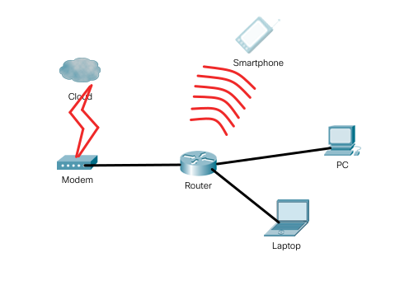

- Bonus question: Is a router enough to have access to the Internet? Explain.

